Dashboard Set-up (Step-by-step Instructions) for Labs on Demand (LOD)
The following step-by-step instructions provide guidance on how to have a fully operational dashboard on Labs on Demand. These instructions go over necessary data preprocessing steps in PostgreSQL and database connection through a server on Tableau.
Start by downloading the following Tableau workbook and SQL script text files:
- D211_Part_1_Data_Dashboards.twbx
- A4. PostgreSQL Data_cleaning (Medical data).txt
- A4. PostgreSQL Data_cleaning (External data).txt
Database Navigation (PgAdmin 4)
- Open PgAdmin 4
- Click on the drop-down arrow next to “Servers (1)”
- Click on the drop-down arrow next to “PostgreSQL 13”
- Click on the drop-down arrow next to “Databases (3)”
- Click on the drop-down arrow next to “medical_data”
- Navigate to the tables under “Schemas” > “Public” > Tables(7)
- Rename the location table and zip column
  - Right-click the table name “location” and go to “Properties”
  - Click in the name field and rename the table to “location_data”
  - Click on the “Columns” tab and rename the “zip” column to “zipcode”
  - Click Save
Troubleshooting
Perform the following steps if your default version of PgAdmin 4 on Labs on Demand has a typo with the high blood pressure column in the patient table.
- Check the preloaded patient table for incorrectly named column:
  - Right click on the “patient” table and go to “Properties”
  - Click on the Columns tab and rename the “hignblood’ column to “highblood”, if necessary.
Add External Data as a New Table in the medical_data Database
- Right-click on Tables(7) and click “Create” > Click on “Table…” and a pop-up window will appear
- Name the table “hospitals”
- Select the Tablespace to “pg_default”
- Click on the “Columns” tab and add the 20 corresponding column names and data types associated with the external hospital data:
- Click “Save”
- Right-click on “hospitals” table > Click on “Import/Export…” > Click on “Export” to toggle the slide to “Import”
- Select the file
  - Check the box to ‘Show hidden files and folders’ if the file is hidden
- Toggle the “Header” to “Yes”
- Select the Delimiter to be a comma
- Click “OK”
Data Preprocessing
- Navigate to “Tools” and click on the down arrow
- Click on “Query Tool”
- Copy and paste the following data cleaning script into the Query Editor:
  - A4. PostgreSQL Data_cleaning.txt
- Run/execute script
- Right click on “Tables” and click “Refresh”
- The following new tables created should appear in the list of tables:
  - location_staging
  - location_staging2
  - patient_staging
  - patient_staging2
  - patient_subset
  - hospital_subset
  - hospital_staging
  - hospital_staging2
Accessing Postgres from Tableau:
- Open Tableau Desktop.
- Navigate to Connect on the left blue pane > Down “To a Server” > Click on “More…” > Click on “PostgreSQL”
- Enter the credentials:
  - Server: localhost
    - Enter as one word, all lowercase letters.
  - Port: 5432
  - Database: medical_data
  - Authentication: should default to Username and Password
    - If it does not, click on the down arrow and select Username and Password
    - Then, enter the Username: postgresql
      - All lowercase letters
    - Password: Passw0rd!
      - Type in the word ‘password’ with a capital ‘P’ and number zero ‘0’ in place of the letter ‘O’
      - End the password with an exclamation point ‘!’
  - SSL is not necessary. Leave that unchecked and then click “Sign in”.
  - Example of pop-up window:
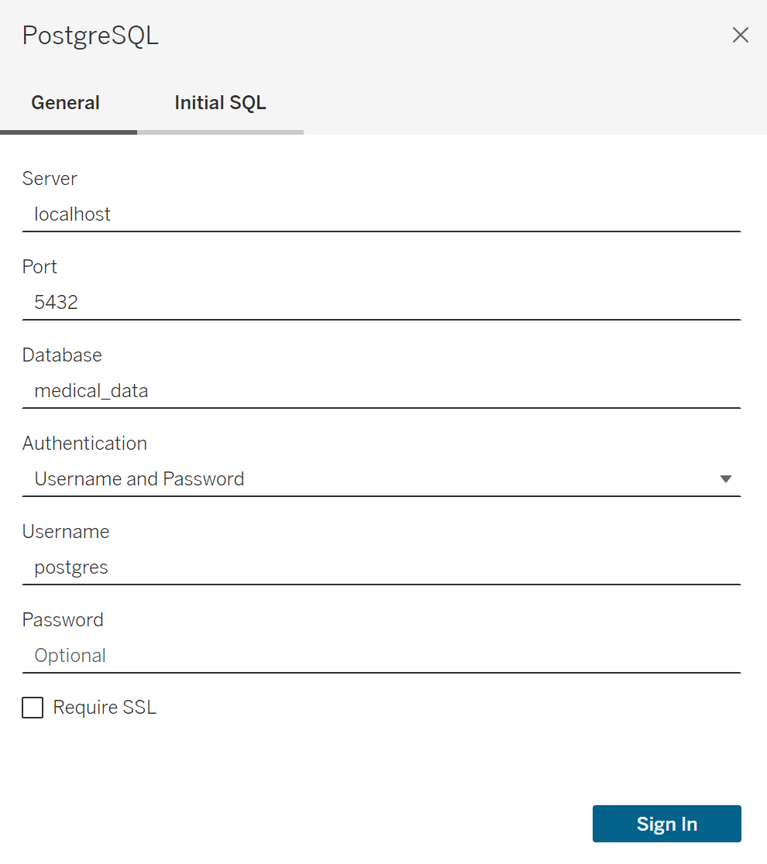
- The credentials are also located in the blue and white pane on the right of the screen.
- Once you have completed the sign in process, Tableau will automatically connect to the localhost PostgreSQL database.
- It will bring up the database that you've selected so that it connects to the PostgreSQL server and the database that you've selected.
- Then, it will bring up all the tables in that database.
Open the Dashboard in Tableau:
- Go “File” > “Open” and browse to the location the dashboard file is saved.
- Select the file and click “Open.”
- Accept Custom SQL Warning > Click “Yes” on the pop-up window
- Enter the password: Passw0rd!
- Click “Sign In”

